NAME:MIRTUNJAY KUMAR

REG NO:16BCE1179

LAB:4 IWP

1:Design a table to display the item code, item name, available quantity of 5 items. Make sure to display the price of an item when the user moves the mouse over the item name of the table.

<!doctype html>

<html>

<head><title>display the price</title></head>

<body>

<table name="t1" border width="10">

<tr><td> item code</td>

<td> item name</td>

<td> available quantity</td>

</tr>

<tr><td>1</td>

<td onmousemove="alert('10')">pen</td>

<td>10</td>

</tr>

<tr><td>2</td>

<td onmousemove="alert('3')">pencil</td>

<td>3</td>

</tr>

<tr><td>3</td>

<td onmousemove="alert('3')">eraser</td>

<td>3</td>

</tr>

<tr><td>4</td>

<td onmousemove="alert('30')">marker</td>

<td>30</td>

</tr>

<tr><td>5</td>

<td onmousemove="alert('10')">chalk</td>

<td>10</td>

</tr>

</table>

</body>

</html>

O/P:

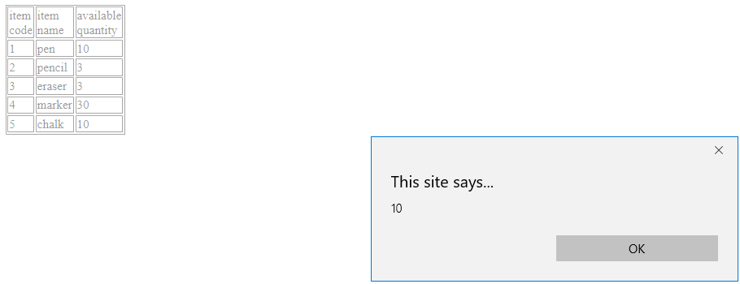

CODE: IMPLEMENTATION USING FUNCTION:

<!doctype html>

<html>

<head><title>display the price</title></head>

<body>

<table name="t1" border width="10">

<tr><td> item code</td>

<td> item name</td>

<td> available quantity</td>

</tr>

<tr><td>1</td>

<td id="p" onmousemove="abc(this.id)">pen</td>

<td>10</td>

</tr>

<tr><td>2</td>

<td id="pn" onmousemove="abc(this.id)">pencil</td>

<td>3</td>

</tr>

<tr><td>3</td>

<td id="e" onmousemove="abc(this.id)">eraser</td>

<td>3</td>

</tr>

<tr><td>4</td>

<td id="m" onmousemove="abc(this.id)">marker</td>

<td>30</td>

</tr>

<tr><td>5</td>

<td id="c" onmousemove="abc(this.id)">chalk</td>

<td>10</td>

</tr>

</table>

<script>

function abc(p)

{

if(document.getElementById(p).innerHTML=="pen")

{

alert("10")

}

else if(document.getElementById(p).innerHTML=="pencil")

{

alert("3")

}

else if(document.getElementById(p).innerHTML=="eraser")

{

alert("3")

}

else if(document.getElementById(p).innerHTML=="marker")

{

alert("30")

}

if(document.getElementById(p).innerHTML=="chalk")

{

alert("10")

}

}

</script>

</body>

</html>

O/P:

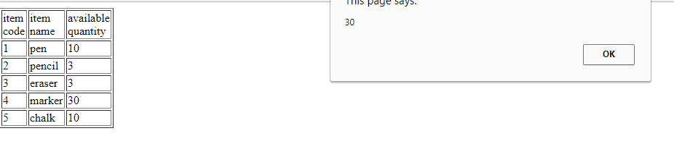

2: SCSE secretary would like to collect the student details (name, register number, mail id, and mobile number).  Design an appropriate GUI for the same and do the validations as below

(i)                  Name length should not be greater than 20 and only allowed special characters are space and . .

(ii)                Mobile number only 10 digits

(iii)               Mail id with alphabets and numbers and only special character is @.

(iv)              Register number should be as per vit format.  (10BCE1001)

Code: for creating form

<!DOCTYPE html>

<html>

<head>

<title>check the validation</title>

</head>

<body>

<table name="t1" border width="10" cellspacing="0" color ="green">

<form name="f1" method="post" action="abc.html" onsubmit="return validate()">

<tr><td>name</td>

<td id="p1"><input type="text" name="n1" placeholder="enter your name" required="required" /></td>

</tr>

<tr>

<td>mobile number</td>

<td id="p2"><input type="text" name="n2" placeholder="enter the number" required="required" /></td>

</tr>

<tr>

<td>email</td>

<td id="p3"><input type="text" name="n3" placeholder="enter your email" required="required" /></td>

</tr>

<tr>

<td>registration number</td>

<td id="p4"><input type="text" name="n4" placeholder= "enter ur regnumber" required="required" /></td>

</tr>

<tr>

<td colspan="2" align="center"><input type=submit ></td>

</tr>

</form>

</table>

</body>

</html>

Java script code for validation :saved as abc.html

Code:

<!DOCTYPE HTML>

<html>

<head>

<script>

function validate()

{

var name= document.f1.n1.value;

var len1=name.length;

var mno = document.f1.n2.value;

var len2=mno.length;

var mail= document.f1.n3.value;

var len3=mail.length;

var reg= document.f1.n4.value;

var len4=reg.length;

var i=0;

if(len1 > 20)

{

alert("name larger than specified length")

}

else

{

for( i;i<len;i++)

{ var s=charCodeAT(name(i))

if((s >=65)&&(s<=90))||((s >=97)&&( s <=122))||( s ===32)||( s ===46))

{

continue;

}

else

{

alert("invalid name");

break;

}

}

}

if(len2===10)

{

for(i=0;i<c;i++)

{

if((mbno.charCodeAt(i)>=48)&&(mbno.charCodeAt(i)<=57))

{

continue;

}

else

{

alert("invalid number");

}

}

}

else

{

alert("invalid number");

}

for(i=0;i<len3;i++)

{

if(((mail.charCodeAt(i)>=65)&&(mail.charCodeAt(i)<=90))||((mail.charCodeAt(i)>=97)&&(mail.charCodeAt(i)<=122))||(mail.charCodeAt(i)===64)||((mail.charCodeAt(i)>=48)&&(mail.charCodeAt(i)<=57))||(mail.charCodeAt(i)===46))

{

continue;

}

else

{

alert("invalid gmail");

break;

}

}

if(len4===9)

{

if((reg.charCodeAt(0)===49)&&(reg.charCodeAt(1)===48)&&((reg.charCodeAt(2)===66)||(reg.charCodeAt(2)===98))&&((reg.charCodeAt(3)===67)||(reg.charCodeAt(3)===99))&&((reg.charCodeAt(4)===101)||(reg.charCodeAt(4)===69))&&(reg.charCodeAt(5)===49)&&(reg.charCodeAt(6)===48)&&((reg.charCodeAt(7)>=49)&&(reg.charCodeAt(7)<=54))&&((reg.charCodeAt(8)>=48)&&(reg.charCodeAt(8)<=57)))

{

alert("valid registration number,name,gmail,phone number");

}

else

{

alert("invalid registration number");

}

}

else

{

alert("invalid registration number");

}

}

alert(name);

alert(len1);

alert(len2);

alert(len3);

alert(len4);

alert(mno);

alert(mail);

alert(reg);

}

</script>

</head>

<body>

<p>the script output not running</p></body>

</html>

o/p

